CHAPTER 15

**COMPOSITES**

**Assignment #32**

15.4 *(a) What is the distinction between cement and concrete?*

*(b) Cite three important limitations that restrict the use of concrete as a structural material.*

*(c) Briefly explain three techniques that are utilized to strengthen concrete by reinforcement.*

15.7 *(a) For a fiber-reinforced composite, the efficiency of reinforcement η depends on fiber length l according to*



*where x represents the length of the fiber at each end that does not contribute to the load transfer. Make a plot of η versus l to l = 40 mm (1.6 in.), assuming that x = 0.75 mm (0.03 in.).*

*(b) What length is required for a 0.80 efficiency of reinforcement?*

HW Note 15.7 Start the calculation at *l* = 2 mm and go to *l* = 40 mm.

15.8 *A continuous and aligned fiber-reinforced composite is to be produced consisting of 30 vol% aramid fibers and 70 vol% polycarbonate matrix; the mechanical characteristics of these two materials are as follows:*

|  |  |  |
| --- | --- | --- |
|  | ***Modulus of Elasticity* [*GPa* (*psi*)]** | ***Tensile Strength* [*MPa* (*psi*)]** |
| *Aramid fiber* | *131 (19 × 106)* | *3600 (520,000)* |
| *Polycarbonate* | *2.4 (3.5 × 105)* | *65 (9425)* |

*The stress on the polycarbonate matrix when the aramid fibers fail is 45 MPa (6500 psi).*

*For this composite, compute the following:*

*(a) The longitudinal tensile strength*

*(b) The longitudinal modulus of elasticity*

**Assignment #33**

15.15 *Compute the longitudinal strength of an aligned carbon fiber-epoxy matrix composite having a 0.25 volume fraction of fibers, assuming the following: (1) an average fiber diameter of 10 × 10-3 mm (3.94 × 10-4 in.), (2) an average fiber length of 5 mm (0.20 in.), (3) a fiber fracture strength of 2.5 GPa (3.625 × 105 psi), (4) a fiber-matrix bond strength of 80 MPa (11,600 psi), (5) a matrix stress at fiber failure of 10.0 MPa (1450 psi), and (6) a matrix tensile strength of 75 MPa (11,000 psi).*

15.19  *For a polymer-matrix fiber-reinforced composite,*

*(a) List three functions of the matrix phase.*

*(b) Compare the desired mechanical characteristics of matrix and fiber phases.*

*(c) Cite two reasons why there must be a strong bond between fiber and matrix at their interface.*

15.D5 *It is necessary to fabricate an aligned and discontinuous carbon fiber-epoxy matrix composite having a longitudinal tensile strength of 1900 MPa (275,000 psi) using 0.45 volume fraction of fibers. Compute the required fiber fracture strength, assuming that the average fiber diameter and length are 8 × 10-3 mm (3.1 × 10-4 in.) and 3.5 mm (0.14 in.), respectively. The fiber-matrix bond strength is 40 MPa (5800 psi), and the matrix stress at fiber failure is 12 MPa (1740 psi).*

**Assignment #34**

16.6 *An electrochemical cell is composed of pure copper and pure lead electrodes immersed in solutions of their respective divalent ions. For a 0.6 M concentration of Cu2+, the lead electrode is oxidized, yielding a cell potential of 0.507 V. Calculate the concentration of Pb2+ ions if the temperature is 25°C.*

16.8 *For the following pairs of alloys that are coupled in seawater, predict the possibility of corrosion; if corrosion is probable, note which metal/alloy will corrode.*

*(a) Aluminum and magnesium*

*(b) Zinc and a low-carbon steel*

*(c) Brass (60 wt% Cu–40 wt% Zn) and Monel (70 wt% Ni–30 wt% Cu)*

*(d) Titanium and 304 stainless steel*

*(e) Cast iron and 316 stainless steel*

16.12 *A thick steel sheet of area 400 cm2 is exposed to air near the ocean. After a 1-year period it was found to experience a weight loss of 375 g due to corrosion. To what rate of corrosion, in both mpy and mm/yr, does this correspond?*

HW Note: 16.12 Ignore the hokey equation 16.23 and solve this from first principles and unit conversions.

**Assignment #35**

16.17 *Lead experiences corrosion in an acid solution according to the reaction*

Pb + 2H+ → Pb2+ + H2

*The rates of both oxidation and reduction half-reactions are controlled by activation polarization.*

*(a) Compute the rate of oxidation of Pb (in mol/cm2-s), given the following activation polarization data:*

|  |  |
| --- | --- |
| ***For Lead*** | ***For Hydrogen*** |
|  |  |
| *i*0 = 2 × 10–9 A/cm2 | *i*0 = 1.0 × 10–8 A/cm2 |
| *β* = +0.12 | *β* = –0.10 |

*(b) Compute the value of the corrosion potential.*

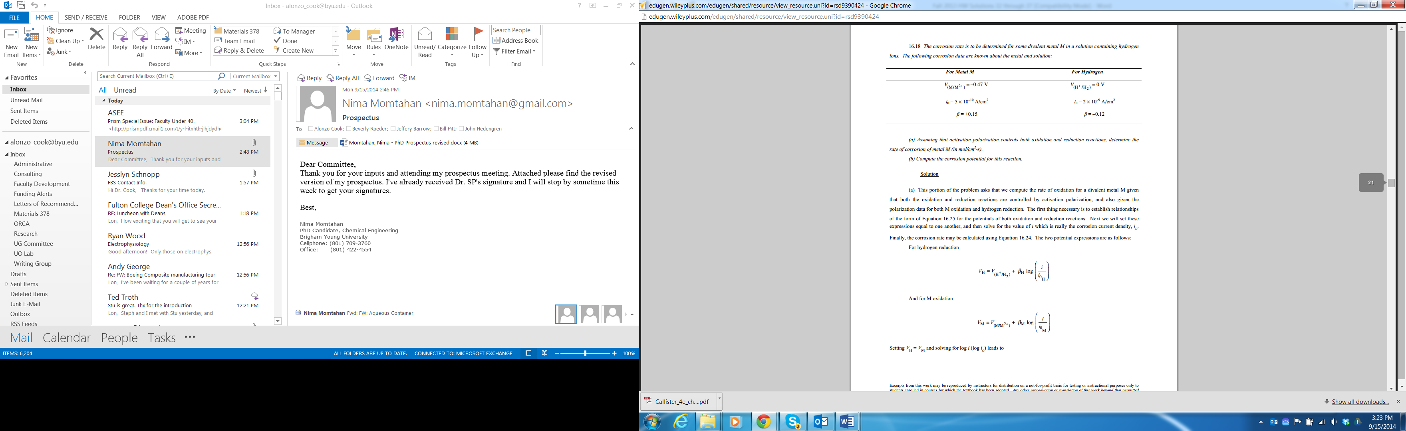

16.19 *The influence of increasing solution velocity on the overvoltage-versus log-current density behavior for a solution that experiences combined activation–concentration polarization is indicated in Figure 16.27. On the basis of this behavior, make a schematic plot of corrosion rate versus solution velocity for the oxidation of a metal; assume that the oxidation reaction is controlled by activation polarization.*

HW Note 16.19 On Fig 16.27, there is no line drawn yet for the cathodic reaction. So to help you, draw a straight line representing the cathodic reaction originating near the “V” of “Velocity” and slopes upward at about a 30° angle and intersects all of the solution velocity curves, as shown below. This will help you understand.



**Assignment #36**

*16.22 For each form of corrosion other than uniform, do the following:*

*(a) Describe why, where, and the conditions under which the corrosion occurs.*

*(b) Cite three measures that may be taken to prevent or control it.*

16.24  *Briefly explain why, for a small anode-to-cathode area ratio, the corrosion rate will be higher than for a large ratio.*

HW Note 16.24 Look at Fig 16.24 for an example of a large anode-to-cathode situation, and reverse the picture for a small anode-to-cathode situation. What is the cathodic reaction? Is there any concentration polarization on the cathodic reaction? So what limits electron flow and the resulting corrosion?

16.27 *Briefly describe the two techniques that are used for galvanic protection.*